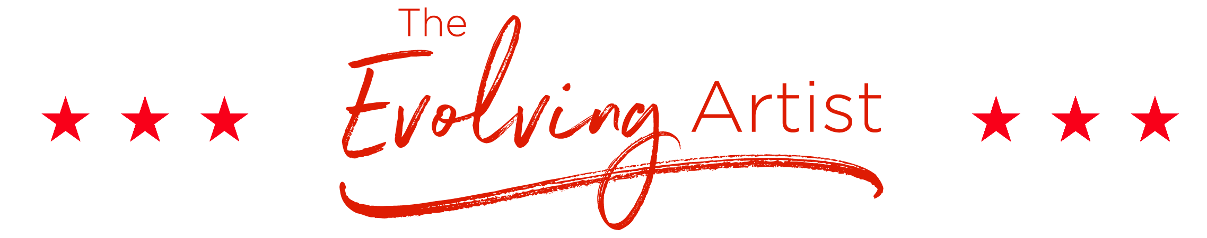
WEEKLY GOAL PLAN: MARCH 26, 2018
LAST WEEK’S ACCOMPLISHMENTS:
Here is where you list all the things you appreciate having accomplished the previous week. Try to word each statement as ‘I appreciate________’. Such as I appreciate that I went for a run or I appreciate that I took my kids on a hike or I appreciate that I cleaned out my closet. Just erase this paragraph and write your own!
CLEAR VISION: I finish the bio for my website this week (write the ONE thing that feels most important and doable this week)
CLEAR ACTIONS:
- Me: Dinner with friends
- Me: Spinning class
- Loved Ones: Hay ride
- Loved Ones: Costume shopping
- Biz: Email to agent
- Biz: Edit chapter 1
- Biz: Meeting with designer
- Biz: Finalize new scheduling system
CLEAR ATTRACTION: I attract all the right people and situations to meet my goals this week
IN QUE: Write anything that comes up throughout the week here, that needs to go on next week’s agenda, so it’s accounted for and you can forget about it and focus on THIS Week ☺

