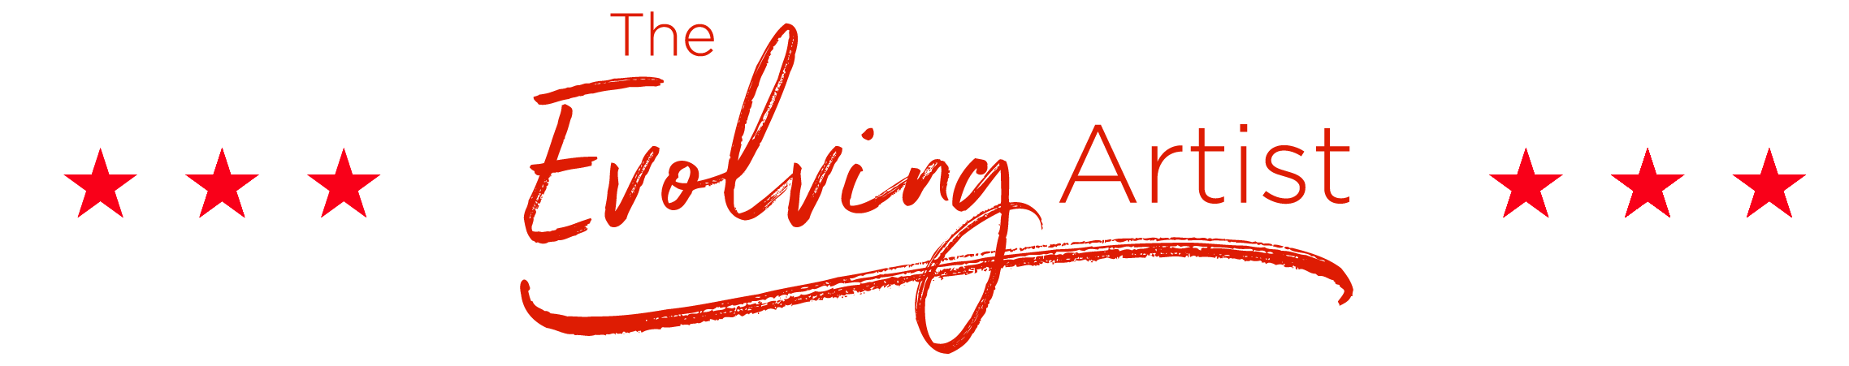
MONTHLY GOAL PLAN: APRIL 2018
LAST MONTH’S ACCOMPLISHMENTS:
I appreciate having a VIP day with Jana, and getting to work with Jove again. I appreciate completing the online course page design, and loving it. I appreciate finishing the About Page copy. I appreciate finishing the Programs Page copy. I appreciate scheduling spring break vacation for me and the kids.
CLEAR VISION: I complete all my webcopy this month
CLEAR ACTIONS:
- Me: Meditation Course
- Me: Fix Car
- Loved ones: Gofundme.com for girls
- Biz: Audio recordings from Paul
- Biz: MR copy complete
- Biz: ELS Copy complete
- Biz: Inside program page design complete
- Biz: Complete blog draft
- Biz: Email training docs to Wendy

CLEAR ATTRACTIONS: I attract all the right people and situations to meet my goals this month

