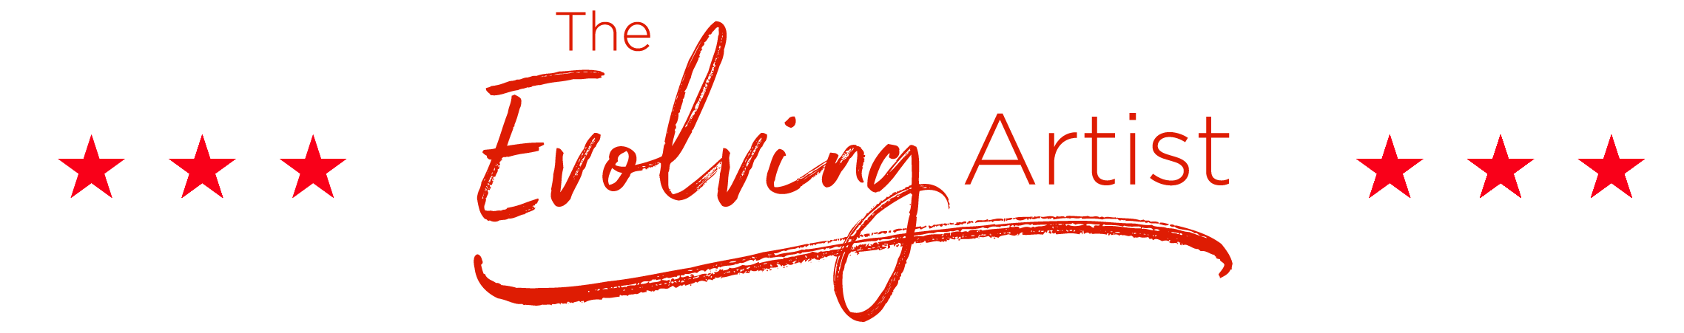
YEARLY GOAL PLAN: 2018
LAST YEAR ACCOMPLISHMENTS:
Here is where you list all the things you appreciate having accomplished the previous year. Try to begin each statement with, “I appreciate________”, replacing this section of the document with everything you appreciate having accomplished last year. For example: I appreciate taking the girls roller skating, to the astrological institute and to the Baba Center twice. I appreciate leading a free workshop at Nourish and Flourish, MCS and also with Murphy’s students. I appreciate running a free webinar and starting my podcast. I appreciate launching my new website and doing my first FB Live Video. I appreciate submitting the proposal to 5 agents and getting new head shots. I appreciate taking a meditation course and feeling more grounded than ever, and I also appreciate opening up to dating again.
CLEAR VISION:
In this area, write your clear vision for this coming year. For example: I see the energy in my body, life and business opening to a deeply satisfying and fulfilling new level this year. I see myself with a super clear, inspiring and popular brand that many people really connect to and trust in. I see my book becoming a bestseller and growing my list to 10,000 people. I see myself taking excellent care of my body, mind and soul and being in the best shape of my life. I see me and the girls having so much fun together and traveling to the aquarium in FL and to CA. I see them really enjoying the development of their talents and me greatly supporting it. I see myself meeting a wonderful man and enjoying getting to know each other. I see myself developing really fun, creative and awesome friendships. I see myself traveling to really great places, like Paris and Mexico, Disneyland and Tahoe. I see myself as really happy, successful, confident, fulfilled, inspired and inspiring.

CLEAR GOALS FOR MYSELF:
- Sit a 10 day meditation course
- Serve a 10 day meditation course
- Run a 5k
- Read 3 autobiographies
- Start regular workout plan

CLEAR GOALS WITH MY LOVED ONES:
- Spring Break—Clearwater Aquarium
- Snowboarding with the kids
- Baba Center
- Ride horses
- Create a birthday list for all

CLEAR GOALS FOR MY BIZ:
- Finish edits on the book
- Cover Design
- Start FB Live Show
- Re-design online programs
- Launch Book

CLEAR ATTRACTION: I attract all the right people and situations to meet or exceed my goals

